### Forward Tilt Automatic Unloading Industrial Washing Machine

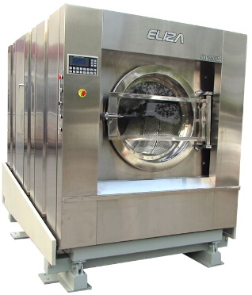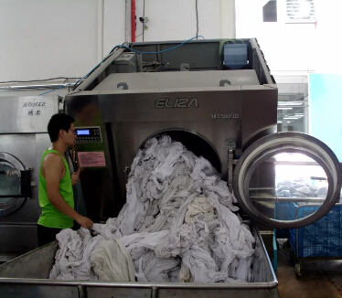

Most advanced design in the industry, stable running, long service life and convenient maintenance  
  
1.The new generation separated type shaft seat system thoroughly solves water leakage issue and guarantees the normal service life of the equipment.  
2.Variable rigidity spring and hydraulic damper suspension structure can absorb vibration by 99.9% and anti-eccentric load ability is as high as 45%. It offers great stability and decrease the abrasion between parts.  
3.Shaft system is easy to maintain.  
4.Touch type LCD computer control panel allows easy operation of the machine. To assure uninterrupted production, a spare computer control system is provided.  
5.No corrosion drain valve prevents connecting rod from sinking into water in order to assure the service life of cylinder sealers.  
6.Full automatic detergent feeding system, with feeding quantity being adjustable.  
7.It can tilt forward by 25 degrees so that textile can automatically unload.  
**Technical Parameters**(Power Source Voltage 380V)

|  |  |  |  |  |
| --- | --- | --- | --- | --- |
| **Model** | **SXT1200FZQ** | **SXT1300FZQ** | **SXT1500FZQ** | **SXT1800FZQ** |
| **Rated Washing Capacity(kg)** | 120 | 130 | 150 | 180 |
| **Motor Power(kw)** | 7.5 | 11 | 15 | 22 |
| **Converter Power(kw)** | 11 | 15 | 18.5 | 30 |
| **Cold and Hot Water Connection Size(mm)** | D50 | D50 | D50 | D75 |
| **Steam Connection Size(mm)** | D25 | D25 | D25 | D25 |
| **Outside Dimensions(mm)** | 1910x2350x2000 | 1940x2500x2100 | 1950x2600x2200 | 2200x2570x2600 |
| **Machine Weight(kg)** | 5500 | 6300 | 6800 | 9950 |